HM489 International Economics

Winter Semester 2023



Name - Divya Kirtikumar Patel

Student ID - 202001420

21 February , 2023

**Introduction**

The objective of this assignment is to examine the correlation between a nation's trade openness and its economic growth. Trade openness signifies the extent to which a country permits the import and export of goods and services with other nations. Essentially, it measures a country's level of receptivity to international trade with respect to its economy. Trade openness can be quantified by dividing a nation's total trade (sum of imports and exports) by its Gross Domestic Product (GDP) at current prices. Economic growth refers to the rise in a country's production of goods and services over time. There are several factors that can be employed to gauge a country's economic growth. In this assignment, economic growth is defined as a percentage change in a country's GDP as compared to the preceding years.

It is widely recognized that the relationship between trade openness and economic growth can differ for developed and developing countries. For developed countries, trade openness tends to have a more positive effect on economic growth, as they have greater access to resources, technology, and markets. In contrast, developing countries may face challenges such as weak institutions, inadequate infrastructure, and lack of access to credit, which can hinder their ability to benefit from trade openness.

Therefore, it is crucial to examine the relationship between trade openness and economic growth in both developed and developing countries separately, taking into account their unique economic characteristics and factors that affect their ability to benefit from trade openness. This study aims to analyzing the relationship between trade openness and economic growth in both developed and developing countries.

**Literature Review**

The relationship between trade openness and economic growth has been extensively studied and debated in the field of economics over the past few decades. The theory that trade liberalization can promote economic growth by increasing efficiency and innovation through greater competition has been established by Jagdish Bhagwati's seminal work. However, empirical studies using various methodologies and data have yielded inconsistent results, with some indicating a positive relationship while others finding no significant or even a negative relationship.

Trade openness has the potential to drive economic growth by facilitating access to a diverse range of goods and services, fostering innovation and competition, and reducing input prices. This, in turn, can lead to increased production, efficiency, and income. For instance, trade liberalization can enable countries to import capital goods, technology, and intermediate products at lower costs, encouraging investment, boosting productivity, and ultimately promoting economic growth.

On the other hand, trade openness may also constrain economic growth, especially in the short run, as it can lead to job losses in domestic industries due to competition from imported goods. Furthermore, the benefits of trade may not be evenly distributed across the population, leading to exacerbation of income inequality.

In summary, the relationship between trade openness and economic growth is complex and may vary across countries and over time. In this assignment, we will explore the relationship between trade openness and economic growth for developed and developing countries using data from the World Bank.

**Data Source**

The data for the study comes from databank of worldbank from the following website

<https://databank.worldbank.org/home.aspx> . I have downloaded three csv one for each export, import and GDP for all countries.

**Data Cleaning -** I have considered time from 2011 to 2021 for doing the analysis. I have also removed the countries which have missing data for any of the three datasets for any year from 2011 to 2021.

**Data Sampling -** I have done random sampling and selected 40 countries each from developed and developing countries so that there is no bias in the analysis and the results are generalizable.

1. **Find the correlation between trade openness and economic growth for developed countries and developing countries respectively**

**Methodology**

There are mainly two ways of finding correlation between two time-series where we don’t have to consider the time-lag mainly spearman correlation and pearson correlation.

Spearman and Pearson correlation are statistical methods used to measure the strength and direction of the relationship between two variables. Pearson correlation measures the linear relationship between two variables, while Spearman correlation measures the monotonic relationship between two variables.

Pearson correlation assumes that the relationship between two variables is linear, meaning that as one variable increases, the other variable also increases or decreases in a constant proportion. On the other hand, Spearman correlation does not assume any specific relationship between the variables but measures the strength and direction of the monotonic relationship, which could be linear or non-linear.

In the case of analyzing the correlation between economic growth and trade openness of countries, Spearman correlation would be more appropriate. This is because the relationship between these two variables is not necessarily linear and could be affected by many factors. Moreover, Spearman correlation is more robust than Pearson correlation when dealing with outliers or non-normal distributions. Economic growth and trade openness data might have outliers or non-normal distributions due to the variations in the economic and political situations of countries. Spearman correlation can handle such situations by ranking the data and calculating the correlation based on the ranks, which makes it more suitable for analyzing non-parametric data.

**Finding Corelation between Economic Growth and Trade Openness using Spearman Correlation**

Spearman's correlation, also known as Spearman's rank correlation coefficient, is a nonparametric measure of the strength and direction of the association between two variables. It is often used when the data is not normally distributed or when the relationship between the variables is not linear.

The Spearman correlation coefficient (ρ) is calculated by first ranking the values of each variable, and then calculating the correlation between the ranks. The formula for the Spearman correlation coefficient is:

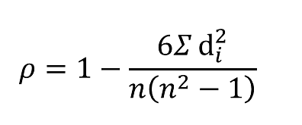

Where :

= sum of the squared differences between the ranks of the two variables

n = number of observations

The value of ρ can range from -1 to +1, where -1 indicates a perfectly negative correlation, +1 indicates a perfectly positive correlation, and 0 indicates no correlation. A value of ρ close to 0 indicates a weak correlation, while a value close to -1 or +1 indicates a strong correlation.

The Spearman correlation coefficient can be calculated using statistical software or by hand. To calculate it by hand, you first need to rank the values of each variable from lowest to highest. Ties are given the average of their ranks. Then, you calculate the difference between the ranks of each pair of observations for each variable, square those differences, and add them up. Finally, you substitute those values into the formula to calculate ρ.

In summary, the Spearman correlation coefficient is a nonparametric measure of the strength and direction of the association between two variables, calculated by ranking the values of each variable and then calculating the correlation between the ranks using the formula:

**Developed Countries:**

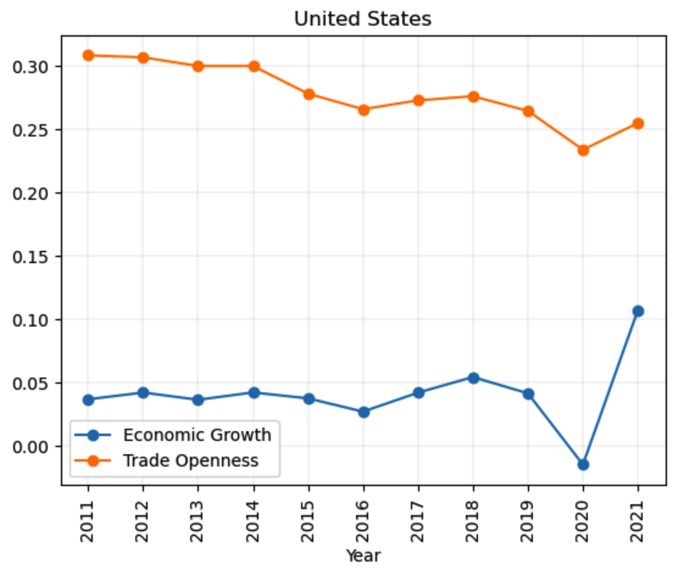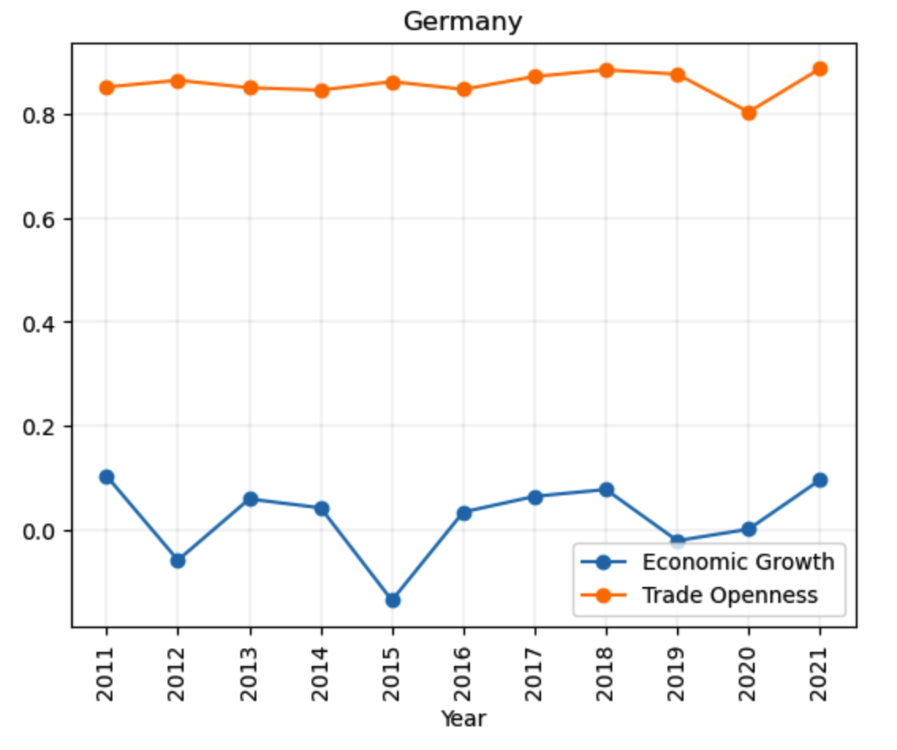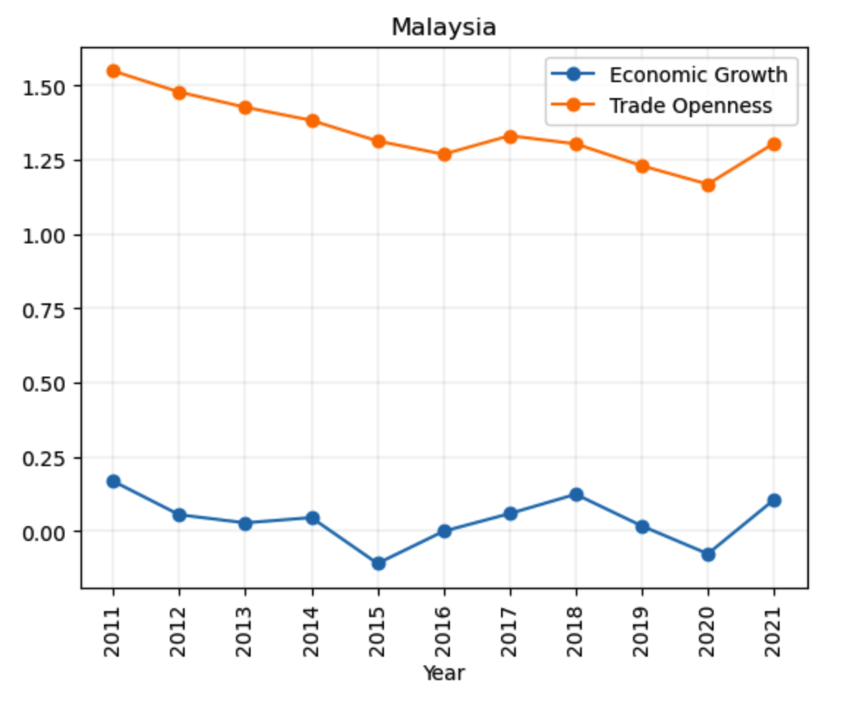

**Developing Countries:**

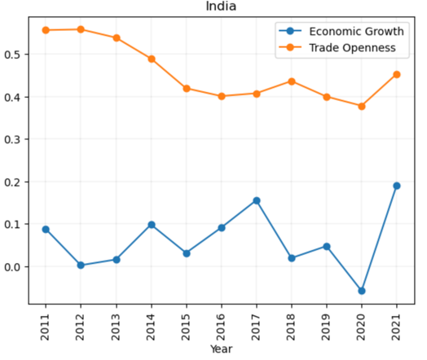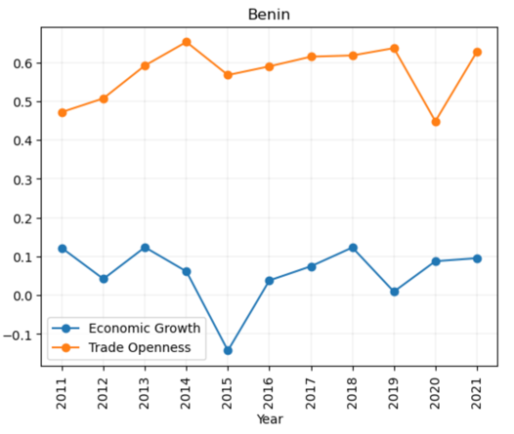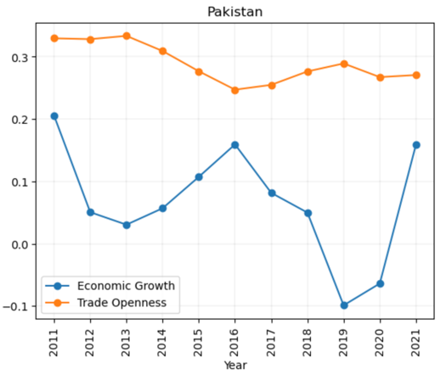

We can observe that developed countries have more stable and more correlated economic growth and trade openness as compared to developing countries.

|  |  |  |  |
| --- | --- | --- | --- |
| Developed Countries | | Developing Countries | |
| Country Name | **Spearman Correlation** | **Country Name** | **Spearman Correlation** |
| Romania | 0.30462768 | **Pacific island small states** | 0.321212121 |
| Sweden | -0.090174963 | **Central African Republic** | 0.163636364 |
| Japan | -0.468327672 | **Tonga** | -0.066666667 |
| Qatar | 0.486873135 | **Ghana** | -0.042424242 |
| Hungary | 0.060426876 | **Nepal** | 0.272727273 |
| United Kingdom | 0.444241853 | **East Asia & Pacific** | 0.806060606 |
| Cyprus | 0.220262568 | **Turkiye** | -0.478787879 |
| Croatia | 0.30282129 | **Burundi** | 0.296969697 |
| Malaysia | 0.634969489 | **Algeria** | 0.503030303 |
| Malta | -0.292330024 | **Armenia** | 0.393939394 |
| Slovenia | 0.396847238 | **Niger** | 0.321212121 |
| Lithuania | 0.295848096 | **Moldova** | 0.115151515 |
| Denmark | -0.222536063 | **Tunisia** | 0.163636364 |
| Kazakhstan | 0.527937039 | **World** | 0.539393939 |
| Singapore | 0.372138416 | **Philippines** | -0.006060606 |
| France | 0.095990888 | **Mauritania** | 0.284848485 |
| Belgium | 0.591510955 | **Zimbabwe** | 0.551515152 |
| Latvia | 0.351080408 | **Europe & Central Asia** | -0.054545455 |
| Luxembourg | -0.199684329 | **Senegal** | -0.418181818 |
| Greece | 0.429018691 | **North Macedonia** | 0.042424242 |
| Ireland | 0.112331086 | **IDA only** | -0.36969697 |
| Portugal | 0.360949221 | **Russian Federation** | 0.078787879 |
| Panama | 0.75853801 | **Nicaragua** | 0.781818182 |
| Israel | 0.088430073 | **Hong Kong SAR, China** | 0.406060606 |
| Switzerland | 0.239958907 | **Zambia** | -0.139393939 |
| Estonia | 0.20272363 | **Jamaica** | 0.406060606 |
| New Zealand | 0.382461775 | **Euro area** | -0.054545455 |
| Thailand | 0.422604472 | **El Salvador** | 0.296969697 |
| Norway | 0.14291841 | **Namibia** | 0.2 |
| Spain | 0.366597965 | **Ukraine** | -0.078787879 |
| Canada | -0.125826652 | **Iran, Islamic Rep.** | -0.612121212 |
| Finland | 0.288582844 | **European Union** | -0.151515152 |
| Chile | 0.378999563 | **Seychelles** | -0.042424242 |
| Poland | 0.277407061 | **Congo, Dem. Rep.** | 0.563636364 |
| Austria | 0.308833981 | **Marshall Islands** | -0.115151515 |
| Italy | 0.154769255 | **IDA blend** | 0.866666667 |
| Georgia | -0.215952823 | **Albania** | 0.636363636 |
| Mauritius | 0.608985785 | **Vanuatu** | -0.163636364 |
| Belarus | 0.40257371 | **Timor-Leste** | 0.515151515 |
| Iceland | 0.355276981 | **India** | -0.078787879 |

**Average Corelation in developed Countries : 0.2438**

**Average Corelation in developing Countries : 0.1664**

**Conclusion**

In developing countries, economic growth and trade openness are not significantly correlated. Developing countries are typically characterized by low levels of economic development and weak institutions, which make it difficult to attract foreign investment and participate effectively in international trade. In such countries, economic growth is driven by factors such as domestic investment, technological innovation, and human capital development. Therefore, the level of trade openness has a negligible impact on economic growth in these countries.

**Gragner Causality Test**

The Granger causality test is a statistical method used to determine whether one time series predicts another time series. It is a popular method used in econometrics, as it is essential to test the relationship between two time series to understand the underlying economic processes. We will discuss how the Granger causality test is best for finding if there is a real correlation between two time series, trade openness, and economic growth, for econometric data.

The Granger causality test is a time-series analysis that identifies the direction of causality between two time series. The test uses the concept of "prediction" to examine whether one time series helps to predict the other. If one time series helps to predict another, then it is said to Granger-cause the other. The Granger causality test is widely used in economics and finance to examine the causality between economic variables.

**Using Granger causality test:**

The Granger causality test is the best method to test the causality between trade openness and economic growth. The test helps to examine whether the changes in trade openness Granger-cause the changes in economic growth or vice versa. The test is based on the idea that if trade openness causes economic growth, then changes in trade openness should help to predict changes in economic growth. Similarly, if economic growth causes trade openness, then changes in economic growth should help to predict changes in trade openness. We use chi square test here for testing in this case.

**Average p-value for developed countries :** 0.295

**Average p-value for developing countries:** 0.468

**Conclusion**

In conclusion, the Granger causality test is an essential tool for examining the causal relationship between two time series, such as trade openness and economic growth. The test helps to determine whether changes in one variable predict changes in another variable or vice versa. As we can see here from low p-value for developed countries we can **claim that developed countries have better correlation between economic growth and trade openness as compared to developing countries.**

1. **Test the hypothesis that mean trade openness of developed countries is greater than that of developing countries using z test (two sample test) at 5 per cent level of significance.**

**Methodology:**

The z-test is a statistical hypothesis test that is used to determine whether a sample mean is significantly different from a known or assumed population mean, when the population standard deviation is known. It is based on the standard normal distribution, which has a mean of zero and a standard deviation of one.

**One-Sided Z-Test:**

A one-sided z-test is used to test a directional hypothesis, that is, to determine whether the sample mean is significantly greater than or less than the population mean. The null hypothesis is typically stated as:

H0: µ = µ0

where µ is the population mean and µ0 is the hypothesized value of the population mean.

The alternative hypothesis can be one-tailed, either greater than or less than, and is typically denoted as:

Ha: µ > µ0 (right-tailed test) or Ha: µ < µ0 (left-tailed test)

The steps for performing a one-sided z-test are as follows:

1. Determine the null and alternative hypotheses.
2. Calculate the test statistic using the formula

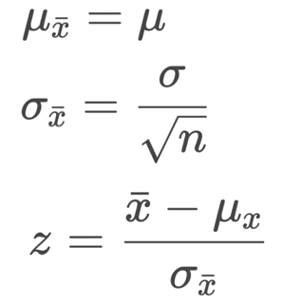 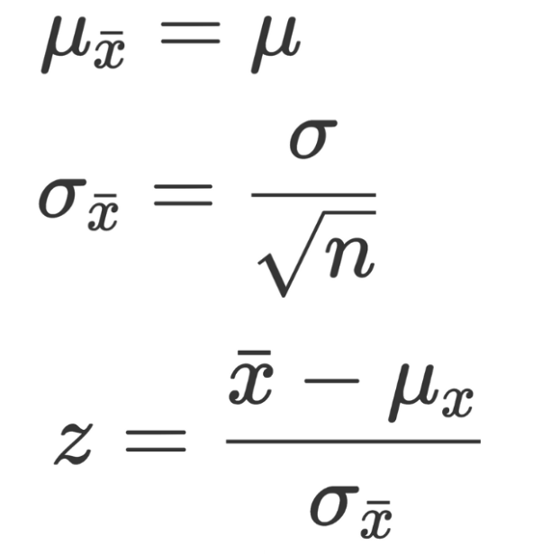

where is the sample mean, σ is the population standard deviation, n is the sample size, and µ0 is the hypothesized value of the population mean.

3. Calculate the p-value from the standard normal distribution table, or using statistical software, based on the calculated test statistic and the direction of the alternative hypothesis.

4. Compare the p-value to the level of significance (α) and reject the null hypothesis if p-value is less than or equal to α.

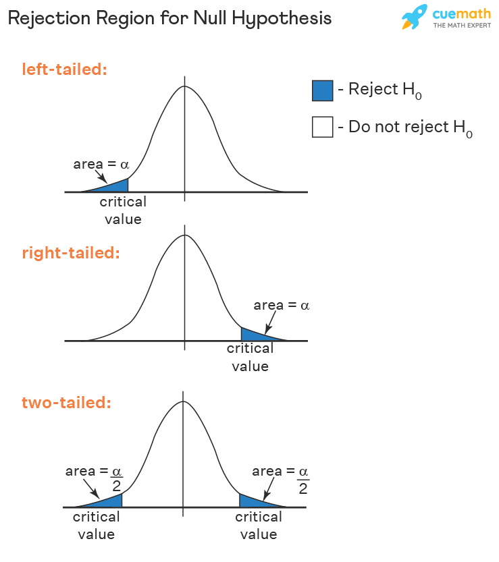

**Two-Sided Z-Test**

A two-sided z-test is used to test a non-directional hypothesis, that is, to determine whether the sample mean is significantly different from the population mean, without specifying the direction of the difference. The null hypothesis is typically stated as:

H0: µ = µ0

where µ is the population mean and µ0 is the hypothesized value of the population mean.

The alternative hypothesis is two-tailed and is typically denoted as:

Ha: µ ≠ µ0

The steps for performing a two-sided z-test are as follows:

1. Determine the null and alternative hypotheses.
2. Calculate the test statistic using the formula:

 

where is the sample mean, σ is the population standard deviation, n is the sample size, and µ0 is the hypothesized value of the population mean.

1. Calculate the p-value from the standard normal distribution table, or using statistical software, based on the calculated test statistic and the two-sided alternative hypothesis.
2. Compare the p-value to the level of significance (α) and reject the null hypothesis if p-value is less than or equal to α/2.

The key difference between the one-sided and two-sided z-tests is the directionality of the alternative hypothesis. In a one-sided test, the alternative hypothesis is directional, whereas in a two-sided test, the alternative hypothesis is non-directional.

In conclusion, the z-test is a powerful statistical tool that can be used to test hypotheses about population means when the population standard deviation is known. It is important to choose the appropriate test (one-sided or two-sided) based on the research question and the directionality of the hypothesis.



In hypothesis testing, the objective is to evaluate the credibility of a hypothesis by assessing the likelihood of observing a certain outcome under specific conditions. In this scenario, we are interested in comparing the mean trade openness of developed and developing countries.

**The first hypothesis (Part B) aims to investigate whether the trade openness of developed countries is greater than that of developing countries.**

Ho : trade openness of developed countries is less than or equal to that of developing countries, while the alternative hypothesis (µdeveloping >= µdeveloped ).

Ha : trade openness of developed countries is greater than that of developing countries (µdeveloping < µdeveloped ).

To test this hypothesis, we use a two-sample Z-test, where we compare the mean trade openness of the two groups. We adopt a right-tailed test since the alternative hypothesis suggests that the trade openness of developed countries is greater than that of developing countries.

z-score = 3.6870989387404434

p-value = 0.00011341259211784112

The Z-score of 3.687 indicates that the mean trade openness of developed countries is 3.687 standard deviations above the mean trade openness of developing countries. This large value of Z-score suggests that the event in null hypothesis is unlikely to occur by chance, providing evidence to support the alternative hypothesis that the mean trade openness of developed countries is greater than that of developing countries.

The corresponding p-value of 0.000113 suggests that there is only a 0.0113% chance that null hypothesis is correct. Since this p-value is less than the significance level of 0.05, we reject the null hypothesis in favor of the alternative hypothesis.

**Conclusion**

From the above results we can conclude that mean trade openness of developed countries is greater than that of developing countries and due to these parameters economic growth of developed countries is more than that of developing countries.

1. **Test the hypothesis that the mean trade openness of developed countries is not equal to that of developing countries using z test (two sample test) at 5 per cent level of significance.**

In Part C, we extend our analysis to investigate whether the mean trade openness of developed countries is different from that of developing countries.

Ho : trade openness of developed countries is equal to that of developing countries, while the alternative hypothesis (µdeveloping = µdeveloped )

Ha : trade openness of developed countries is less than or greater than that of developing countries (µdeveloping> µdeveloped or µdeveloping < µdeveloped )

To test this hypothesis, we again use a two-sample Z-test, but this time we adopt a two-tailed test since the alternative hypothesis is not directional. Using a significance level of 5%, we calculate the critical values of the Z-test to be +1.96 and -1.96.

We calculate the Z-score for the observed difference in means between the two groups, which is 3.687.

z-score = 3.6870989387404434

p-value = 0.00022682518423568224

The Z-score of 3.687 indicates that the observed difference in means between the two groups is 3.687 standard deviations away from the null hypothesis mean of 0. This large Z-score suggests that the event in null hypothesis is unlikely occur by chance, providing evidence to support the alternative hypothesis that the mean trade openness of developed countries is not equal to that of developing countries.

The corresponding p-value of 0.000227 suggests that there is only a 0.0227% chance of correctness of null hypothesis. Since this p-value is less than the significance level of 0.05, we reject the null hypothesis in favor of the alternative hypothesis.

**Conclusion**

We have used a two-sample Z-test to compare the mean trade openness of developed and developing countries, and our results indicate that mean trade openness of developed countries is not equal to that of developing countries.

**Inferences**

The findings of the analysis suggest that developed countries tend to exhibit better economic growth than their developing counterparts, and this can be attributed to higher levels of trade openness. The analysis reveals a strong positive correlation between trade openness and economic growth rates in developed nations. This correlation implies that as the level of trade openness increases, the rate of economic growth also tends to increase.

Moreover, it can be hypothesized that the mean trade openness of developed countries is greater than that of developing countries due to their higher GDP levels and stronger correlation between trade openness and economic growth. Developed countries tend to have more robust economies, which provide them with greater opportunities for trade, leading to higher levels of trade openness. In addition, the analysis indicates that as the level of economic development increases, countries tend to become more open to trade.

The results also suggest that developed countries tend to be more involved in international trade than developing countries, indicating a greater willingness to engage with other nations in the global marketplace. This could be driven by a desire to take advantage of the benefits of globalization, such as increased access to new markets, sources of innovation and technology, and economies of scale. This trend could further reinforce the higher levels of trade openness observed in developed countries.

However, the analysis also indicates that developed countries tend to impose lower import tariffs compared to developing countries. This could be disadvantageous for developing countries as they may face higher taxes on exported goods, making it more difficult for them to compete in the global market. The higher taxes on exports in developing countries could also lead to lower levels of trade openness and slower economic growth rates.

In conclusion, the analysis highlights the importance of trade openness for economic growth and suggests that developed countries tend to exhibit higher levels of trade openness due to their higher GDP levels and stronger correlation between trade openness and economic growth. However, the lower import tariffs imposed by developed countries could disadvantage developing countries in the global market, underscoring the need for fair trade policies that enable all countries to compete effectively in the global marketplace.

**References:**

Wikipedia contributors. (2022, February 4). Granger causality. In Wikipedia. Retrieved February 21, 2023, from <https://en.wikipedia.org/wiki/Granger_causality>

Ding, Z., Granger, C. W. J., & Engle, R. F. (1993). A long memory property of stock market returns and a new model. Journal of Empirical Finance, 1(1), 83-106. <https://doi.org/10.1016/0927-5398(93)90006-D>

Wikipedia contributors. (2022, February 6). Spearman's rank correlation coefficient. In Wikipedia. Retrieved February 21, 2023, from <https://en.wikipedia.org/wiki/Spearman%27s_rank_correlation_coefficient>

Wikipedia contributors. (2022, February 20). Pearson correlation coefficient. In Wikipedia. Retrieved February 21, 2023, from <https://en.wikipedia.org/wiki/Pearson_correlation_coefficient>

Scribbr. (2022, January 4). Pearson correlation coefficient: Definition and calculation. Retrieved February 21, 2023, from <https://www.scribbr.com/statistics/pearson-correlationcoefficient/#:~:text=The%20Pearson%20correlation%20coefficient%20(r,the%20relationship%20between%20two%20variables>

**Code for this results:**

<https://colab.research.google.com/drive/1KdQXvN-10zWFtWUqqfO9SFqcgWKCWhee?usp=sharing>